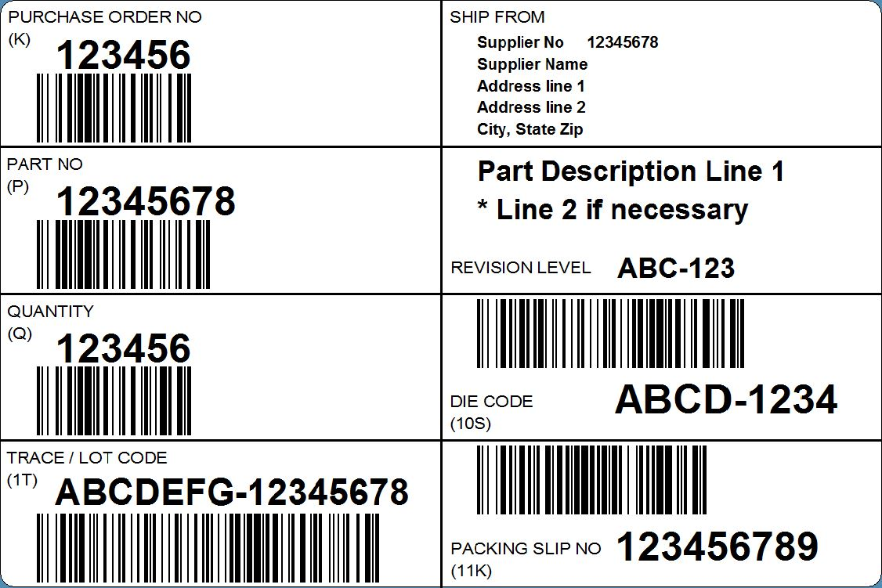
SUPPLIER SHIPPING LABEL STANDARD
WHITE SPACE
Each barcode on the label should have a minimum of 1/4” of white space before and after it.
SAFETY SYMBOL
If the part is designated as having a Customer Critical Characteristic, one of three safety symbols must be placed in upper right corner of part# box:
- Inverted delta (shown)
- The characters “<CC>”
- The words “Safety Item”
BARCODE SYMBOLOGY
All barcodes on the label should be either Code128 (shown), or Code39. Code128 places more characters in less space than Code39 does.
PACKING SLIP NO
Your packing slip number is desired, but not required.
DIE CODE
Die code is only required if the part is a forging.
DATA IDENTIFIERS
Every barcoded field has its own data identifier shown in parenthesis. The identifier is not part of the human readable text, but is at the beginning of the barcode. Example: if you scan the quantity barcode field, the result should be Q123456.
OFFSET BARCODE ROWS
Any barcode in the same row as another barcode must be offset to not be in the same scanner line as the first.
TRACE / LOT CODE
This field is your lot traceability code. In the event of a failure, this is the code we will give you to retrieve your production and material information from.
December, 2016

*All data fields shown are required unless otherwise stated.

6” or 6½”

4”

